**Professional Development and Job Satisfaction Among Government-Aided School Teachers: A Study from Valsad District, Gujarat**

**Kumari Puja Kanakshi Thakor1, Dr. Pavankumar2**

1Research Scholar, Department of Education, Madhav University, Pinwara, Rajasthan, India

2Professor, Department of Education, Madhav University, Pinwara, Rajasthan, India

|  |  |  |
| --- | --- | --- |
| A R T I C L E I N F O |  | A B S T R A C T |
| **Article History:**  Accepted : 01 July 2025  Published: 19 July 2025 |  | This study explores the professional development practices and their impact on job satisfaction among government-aided elementary school teachers in the Valsad District, Gujarat. Through a structured survey, quantitative data were collected on variables such as work hours, training participation, administrative support, and perceived value of appraisals and development programs. Findings show that while professional development is widely offered and attended, its perceived impact on teaching quality, salary, and job satisfaction remains moderate. Most teachers agree that their efforts are acknowledged, and regular appraisals are conducted, but they express skepticism regarding the tangible outcomes of those evaluations. The study highlights the need for targeted, meaningful development programs and greater alignment between appraisal systems and professional growth incentives.  **Keywords :** Teacher Satisfaction, Professional Development, Appraisal, Government-Aided Schools, Gujarat |
| **Publication Issue :**  Volume 12, Issue 4  July-August-2025  **Page Number :**  466-474 |

**1. Introduction**

Teacher job satisfaction is universally acknowledged as a cornerstone of quality education. It influences not only how educators perform in the classroom but also how they engage with the broader goals of education reform, student achievement, and institutional development (Evans, 1998; Dinham & Scott, 1998). In the Indian education system, especially in government-aided schools, the challenge of ensuring consistent teacher satisfaction is intensified by infrastructural constraints, uneven policy implementation, and limited access to quality professional development programs (OECD, 2005). With the changing educational landscape that emphasizes accountability, continuous learning, and inclusive practices, it is essential to understand how teachers perceive their roles and responsibilities, and whether they feel adequately supported in fulfilling them. This research focuses on government-aided school teachers in Valsad District, Gujarat, where schools operate under hybrid administrative models, combining government funding with private management. The study aims to explore the dimensions of professional development, appraisal systems, and time management, and how these factors relate to teacher satisfaction. It seeks to uncover whether current professional development efforts are effective, whether teachers find appraisals meaningful, and how these processes impact motivation, recognition, and retention. In recent years, the Government of India has advocated for improving teacher quality through initiatives such as the National Education Policy (NEP) 2020, which emphasizes teacher training and performance assessment. However, local-level studies are required to assess how well such policies are implemented and whether they translate into tangible improvements in school environments. A district-level case study such as this provides a detailed view into real classroom realities and can inform broader educational reforms by grounding them in lived teacher experiences.

**1.1 Research Objectives**

* To assess how government-aided school teachers manage their time across duties.
* To explore the frequency, accessibility, and impact of professional development.
* To understand teachers’ views on appraisal systems and their effects on rewards, job security, and satisfaction.

To identify gaps in development initiatives and suggest improvements.

**2. Literature Review**

**2.1 Job Satisfaction: A Multidimensional Concept**

Job satisfaction among teachers has long been studied as a function of both intrinsic and extrinsic motivators. Herzberg’s (1966) two-factor theory outlines this clearly by distinguishing between hygiene factors (e.g., salary, working conditions) and motivators (e.g., recognition, personal growth). Spector (1997) also emphasized that workplace satisfaction arises from an interplay of organizational, personal, and societal influences. Evans (1998) asserts that satisfaction is often subjective and context-specific, but critical for sustaining enthusiasm and professional dedication. For teachers, this translates into feelings of being respected, having a sense of achievement, and working in environments conducive to their professional needs. Dinham and Scott (1998) proposed a three-domain model which includes intrinsic rewards (like student success), school-level factors (like leadership), and broader systemic elements (like policy and pay structures). These frameworks collectively help interpret how different institutional arrangements affect teacher morale.

**2.2 Professional Development and Teacher Motivation**

Professional development is central to teacher effectiveness and satisfaction. When training opportunities are aligned with teachers’ needs and interests, they can enhance not only skills but also self-worth and commitment (Caprara et al., 2003). Day and Gu (2009) found that veteran teachers who regularly engage in meaningful professional development are more resilient and adaptable. However, research by Perie and Baker (1997) and Pithers and Soden (1998) warns that poorly designed or administratively motivated training can have the opposite effect—leading to stress, disinterest, or burnout. In the Indian context, professional development is often perceived as compliance-based rather than needs-driven, leading to low engagement and limited long-term impact (Liu & Onwuegbuzie, 2012). This discrepancy is reflected in studies showing that while training sessions are often attended (OECD, 2005), their effectiveness remains limited unless they are participatory, contextual, and action-oriented (Schaufeli & Bakker, 2004). In Valsad’s government-aided schools, where infrastructure and policy support may vary, professional development must be customized. This study reveals that even though 100% of surveyed teachers participated in some form of professional training, nearly half reported no significant enrichment (Table 3). This finding is consistent with research by Alam and Farid (2011), who stress the importance of training relevance in driving teacher motivation.

**2.3 Appraisal Systems and Feedback Mechanisms**

Teacher evaluation systems are essential for accountability and growth, yet their execution often determines whether they inspire or demoralize (Ingersoll, 2001). A system perceived as fair and supportive can build trust and increase job satisfaction (Johnson & Birkeland, 2003). However, Hagedorn (2000) observed that when reviews are used solely for administrative compliance, their potential to contribute to development is lost. In this study, all respondents stated they receive at least annual feedback from their principals (Table 5), and 100% agreed that it was fair and useful. Despite this, only 20.83% reported any change in job satisfaction or career advancement as a result. This reflects similar trends noted by Leithwood and Jantzi (2006), who argue that transformational leadership is key in ensuring appraisals lead to actionable growth. Zembylas and Papanastasiou (2004) also caution that teacher recognition must be both symbolic and material—meaningful feedback coupled with promotions, bonuses, or public acknowledgment. The perceived disconnect between feedback and reward in this research echoes OECD (2005) findings that many teachers feel evaluations are not tied to any real incentives. For an appraisal system to drive performance, it must not only identify areas for improvement but also offer rewards and development pathways aligned with those areas (Tickle, Chang, & Kim, 2011).

**3. Methodology**

**3.1 Research Design**

This study employed a **descriptive quantitative research design** to investigate the nature and extent of job satisfaction and professional development experiences among teachers working in government-aided elementary schools in the Valsad District of Gujarat, India. The descriptive design was chosen for its suitability in capturing numerical trends, participant perspectives, and observable patterns within a defined population. This approach allowed the researchers to systematically examine variables such as time allocation, training participation, and teacher perceptions on appraisal and professional growth, all of which are critical indicators of workplace satisfaction and institutional effectiveness.

Quantitative methods are particularly well-suited for studies aiming to generalize findings across a specific educational population, and in this case, the use of a structured survey facilitated uniform data collection and comparative analysis (Creswell, 2014). The research sought not to intervene or manipulate any variables, but rather to describe the existing practices and perspectives within the sampled group.

**3.2 Population and Sample**

The population for the study consisted of government-aided elementary school teachers operating under various administrative and funding models across Valsad District. These schools receive financial support from the government but often maintain independent management structures, making them a unique hybrid within India’s education system.

Teachers from this category were selected based on their relevance to the study’s objectives. A **purposive sampling method** was employed, focusing specifically on **experienced teachers** with several years of service. This non-probability sampling technique was appropriate for selecting participants who could provide informed and reflective responses about long-term exposure to institutional practices, professional development programs, and appraisal systems (Etikan, Musa, & Alkassim, 2016).

While the total number of respondents was modest, the sample was considered representative of the broader teaching community in government-aided schools, particularly in terms of years of service, engagement with development programs, and institutional familiarity.

**3.3 Data Collection Tool**

The primary instrument for data collection was a **structured questionnaire**, designed to gather quantifiable responses related to:

* Weekly time spent on teaching, planning, administrative duties, and other school-related activities.
* Participation in professional development activities, including workshops, training programs, and scheduled school-level meetings.
* Impact of training on teacher satisfaction, performance, and professional growth.
* Experiences with and perceptions of appraisal systems, including feedback frequency, fairness, and its effect on career outcomes.

The questionnaire included **close-ended items**, many of which used **Likert-type scales** to gauge the degree of agreement or impact (e.g., “no impact” to “large impact”). Multiple-choice and check-box formats were used for categorical variables such as years of experience, participation frequency, and type of training attended. This design ensured consistency in responses and facilitated straightforward statistical analysis.

The questionnaire was initially piloted with a small group of teachers outside the target sample to refine clarity, language, and item validity. Based on pilot feedback, some items were modified to enhance contextual relevance and respondent comprehension.

**3.4 Data Collection Procedure**

The final version of the questionnaire was distributed in both **paper-based and digital formats** to ensure maximum accessibility and participation, especially for teachers in remote or low-connectivity areas. Field visits were conducted in schools located in different talukas of Valsad, while digital platforms such as email and WhatsApp were used for teachers who preferred electronic communication.

Participation was voluntary and anonymous, and respondents were assured of the confidentiality of their responses. The data collection process spanned **approximately four weeks**, with periodic follow-ups to increase the response rate and ensure complete data sets.

**3.5 Data Analysis**

Once collected, data were compiled using **Microsoft Excel** and statistically analyzed using **SPSS (Statistical Package for the Social Sciences)**. The primary methods of analysis included **frequency counts, percentage distributions**, and **cross-tabulations** to identify trends and relationships across key variables. This analytical strategy allowed the researchers to interpret the quantitative findings with clarity, revealing the most common perceptions, experiences, and practices among the teachers surveyed.

The use of **content and percentage analysis** was particularly important for interpreting patterns in professional development participation, time management, and appraisal impact. The emphasis was placed on understanding the broader implications of these practices on teacher motivation, satisfaction, and institutional effectiveness.

**4. Results and Analysis**

Content and percentage analyses were performed on the survey data. What follows is a tabular presentation of the findings. In order to compare the levels of work satisfaction across government-aided schools, the research sought to gather data pertaining to the goals.

**Table 1 : Distribution of Weekly Working Hours of Government-Aided School Teachers Across Teaching, Planning, Administration, and Other Activities**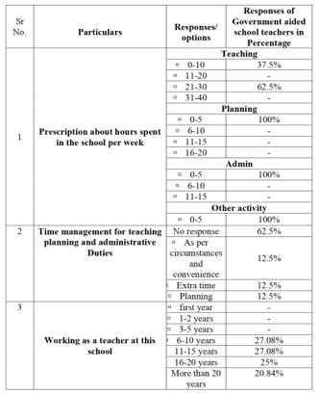

This table presents how government-aided school teachers allocate their time across core professional responsibilities during a typical workweek. The data reveal that 62.5% of teachers spend between 21 to 30 hours per week on teaching activities, while the remaining 37.5% allocate only 0 to 10 hours, indicating a disparity likely influenced by administrative duties or part-time roles. Notably, 100% of respondents reported spending just 0 to 5 hours per week on planning, administrative tasks, and other school-related activities, suggesting a possible undervaluation of these essential yet often invisible aspects of teaching. The limited time dedicated to planning and administration could either reflect high teaching loads or insufficient institutional emphasis on structured preparation and school management tasks. This insight underscores the need for more balanced time management structures that prioritize planning and administrative engagement, critical for effective pedagogy and school functioning.

**Table 2 : Time Management Practices, Teaching Experience, and Participation in Professional Development Activities**

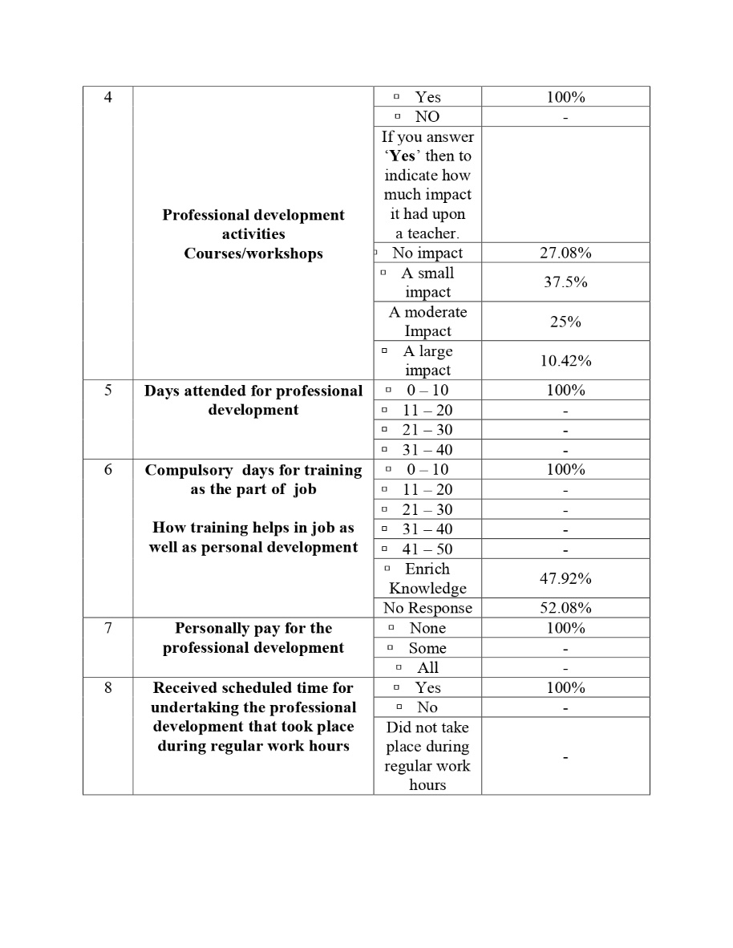

This table highlights teachers’ strategies for managing teaching, planning, and administrative duties, alongside their years of teaching experience and initial involvement in professional development. A majority (62.5%) of teachers gave no specific response about their time management strategies, though a small but equal proportion (12.5%) cited working during extra hours, planning, or personal convenience. Regarding teaching tenure, the data show a well-distributed experience range, with the largest group falling within the 6–10 and 11–15 years categories (each around 27%). This indicates a mature workforce likely capable of adapting to institutional demands. Additionally, all teachers reported having attended professional development activities such as workshops and courses, though their perceived impact varied. While 27.08% reported no impact, the majority (62.5%) saw at least a small to moderate benefit, suggesting that while training is universally provided, its practical utility in teaching varies and may benefit from reform in content or delivery.

**Table 3 : Scheduled Support, Financial Commitment, and Institutional Provisions for Professional Development**

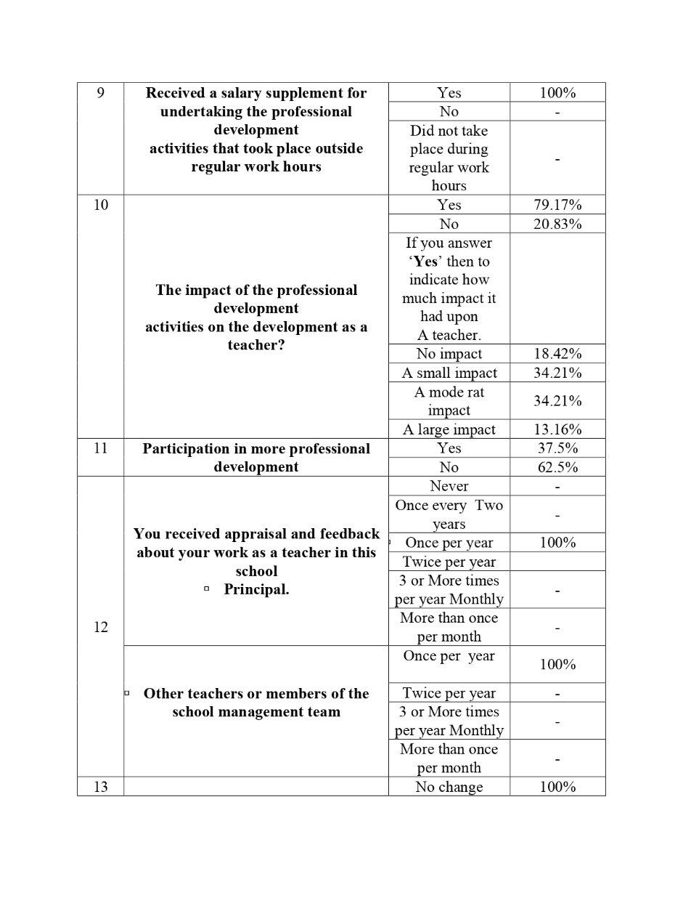

Table 3 evaluates institutional backing for professional development, including whether training occurs during scheduled hours, is compensated, and if teachers are required to fund it themselves. A striking 100% of respondents confirmed receiving time within regular work hours for such training, and all reported that any development activity held outside these hours was supplemented by salary adjustments—indicating strong institutional support. However, no teacher had to personally fund their development, implying either full sponsorship or centrally organized programs. Despite this, only 47.92% acknowledged that training enriched their knowledge, with over half (52.08%) offering no clear view, hinting at a disconnect between program implementation and perceived learning gains. These results emphasize that while logistical and financial support systems for training are robust, there remains a need to improve content quality and relevance to enhance its practical outcomes.

**Table 4 : Impact of Professional Development Activities on Career Advancement and Job Responsibilities**

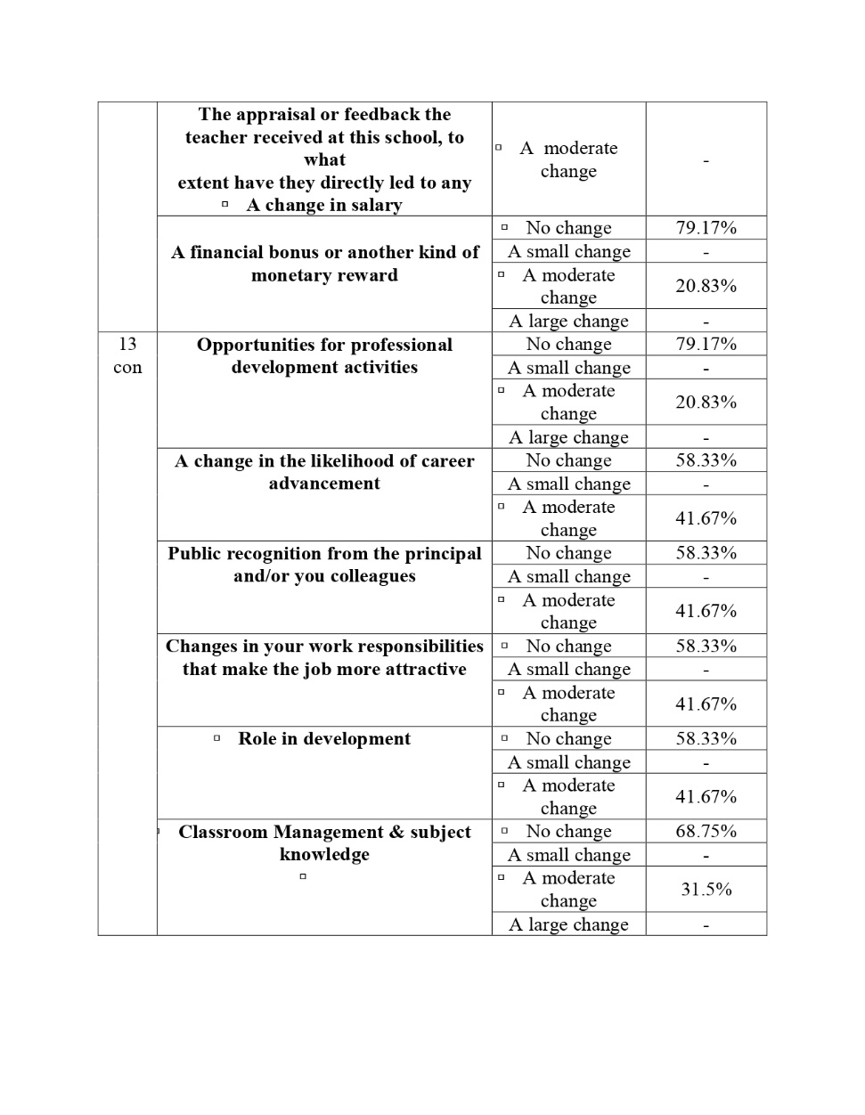

This table explores the perceived effects of professional development on various dimensions of teachers' careers. Most respondents acknowledged that training had a moderate impact on their roles, particularly regarding knowledge enhancement and new responsibilities. However, 62.5% did not participate in additional training beyond what was mandated, which may limit the scope of professional growth. When asked whether training influenced career advancement, public recognition, or changes in work responsibilities, around 41.67% perceived a moderate impact, yet a majority still saw no change across categories such as monetary rewards, professional development opportunities, or job attractiveness. This data suggests that while teachers recognize the potential of development programs to influence their roles, the actual systemic translation of these programs into tangible career progression remains limited. Institutional frameworks must, therefore, more effectively integrate training outcomes into promotional and evaluative structures.

**Table 5 : Teacher Perceptions on Fairness and Effectiveness of Appraisal Systems in Government-Aided Schools**

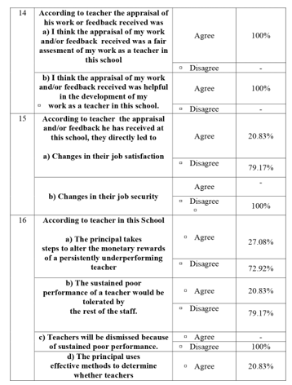

Table 5 offers insight into how teachers perceive the appraisal and feedback systems in their schools. A full 100% of teachers agreed that the appraisal they received was fair and helpful for their development—an encouraging sign that evaluation mechanisms are viewed as constructive rather than punitive. However, only 20.83% believed that these evaluations led to improvements in job satisfaction, with none acknowledging gains in job security. This disconnect suggests that while teachers value feedback for personal or pedagogical growth, it does not necessarily correlate with their broader professional experience or sense of stability. It highlights a gap between performance evaluations and actionable institutional responses, such as promotions, benefits, or leadership opportunities. Bridging this gap requires aligning appraisal systems more closely with career development pathways, so that feedback becomes a lever not just for growth but for retention and advancement.

**Table 6 : Administrative Feedback, Reward Systems, and Teacher Engagement in School Vision Activities**

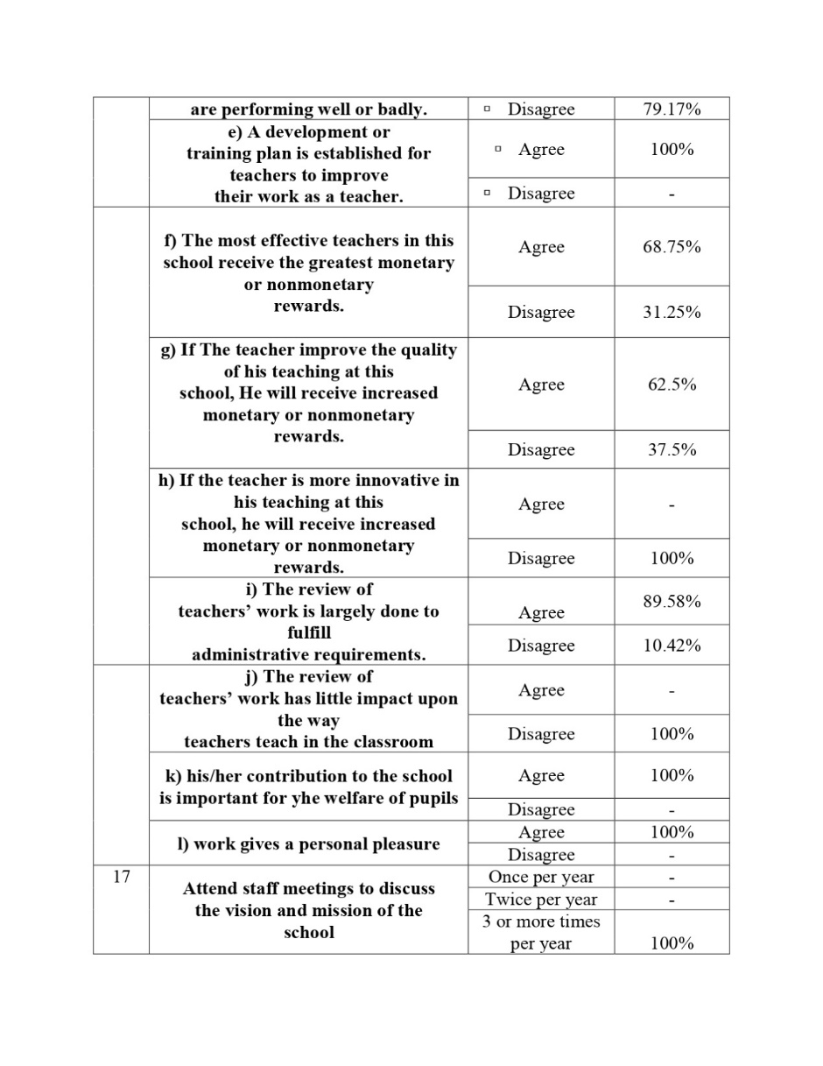

This final table investigates the role of school leadership in reward distribution, performance management, and fostering a culture of inclusion in decision-making. Teachers’ perceptions of leadership accountability reveal mixed responses. While 27.08% agreed that the principal actively manages monetary rewards for underperforming teachers, the majority (72.92%) disagreed, pointing to a possible leniency in performance enforcement. Notably, 100% disagreed that poor performance leads to dismissal, and 79.17% believed no formal criteria exist to judge teaching quality. Despite these concerns, 100% of respondents believed that their contribution supports pupil welfare and that their work brings personal fulfillment, reflecting strong intrinsic motivation. Additionally, teachers were unanimously engaged in regular staff meetings to discuss the school’s vision, indicating a collaborative institutional environment. This data emphasizes that while systems for accountability may be weak, teacher morale and commitment remain high—an asset that school leaders must leverage through transparent, equitable reward systems and more rigorous performance evaluation strategies.

**5. Discussion**

The present study offers a detailed exploration into the professional development practices and job satisfaction of government-aided school teachers in Valsad District, Gujarat. One of the most compelling insights is the apparent disconnect between widespread participation in professional development and its perceived utility in enhancing teachers' roles, recognition, or advancement. While all respondents acknowledged attending mandated training, only a minority believed it had a meaningful impact on their teaching performance or career trajectory. This observation echoes Hagedorn’s (2000) assertion that professional growth opportunities, to be effective, must align with personal and institutional goals, and must be embedded in systemic reward structures to influence long-term job satisfaction.

The fact that teachers reported moderate to low gains from professional development despite universal access highlights a common pitfall in top-down educational interventions. As noted by Perie and Baker (1997), development initiatives often fail when they are disconnected from actual classroom needs. Similarly, Liu and Onwuegbuzie (2012) emphasized that training rooted in administrative mandates rather than participatory learning models can lead to disengagement. In our study, 52% of teachers expressed uncertainty about the value of their training, reinforcing what Pithers and Soden (1998) identified as a mismatch between professional development delivery and real-world classroom challenges. This points to the need for contextualized, subject-specific, and practice-oriented training modules tailored to local school realities, especially in diverse regions like Valsad where school infrastructure and administrative models vary significantly.

Another dimension explored in the study is teacher appraisal and feedback. It is encouraging that 100% of the respondents found their evaluations fair and professionally conducted. This supports findings by Johnson and Birkeland (2003) and Dinham and Scott (1998), who highlight that when appraisals are perceived as just and constructive, they can contribute to morale and motivation. However, the perceived lack of correlation between feedback and tangible benefits, such as promotions, bonuses, or enhanced job security, is a concern. As Ingersoll (2001) noted, performance evaluations that lack follow-through or institutional consequence often lose their meaning and can contribute to job stagnation.

This issue becomes even more pressing when viewed through the lens of Herzberg’s (1966) motivation-hygiene theory. While positive appraisals and training experiences fall under the category of motivators, their failure to translate into rewards or opportunities places them into an ambiguous space that may ultimately lead to dissatisfaction. Evans (1998) also reminds us that recognition without systemic backing can lead to superficial engagement. Teachers in the study expressed skepticism regarding whether evaluations and training improved their salary, responsibilities, or upward mobility—a pattern consistent with Skaalvik and Skaalvik (2011), who observed that absence of institutional responsiveness can diminish intrinsic motivation over time. Interestingly, despite these shortcomings, the teachers surveyed demonstrated high levels of intrinsic motivation and commitment. Every respondent reported finding meaning in their work and supporting their institution’s vision. This aligns with Caprara et al. (2003), who emphasized that strong self-efficacy and a sense of purpose can act as protective factors against systemic deficiencies. Similarly, Zembylas and Papanastasiou (2004) noted that while salary and advancement are critical, the internal satisfaction derived from contributing to student development is a significant driver of teacher retention. However, as Judge and Klinger (2008) argue, relying solely on intrinsic motivation without structural reinforcement is unsustainable and may lead to burnout—particularly in the absence of external incentives or institutional support. The study also raises important considerations regarding workload distribution and time management. The findings show that while most teachers devote significant time to teaching, very little is allocated for planning, administrative tasks, or collaborative activities. This raises concerns about whether sufficient attention is being paid to holistic teaching practices that involve curriculum planning, reflective work, or inter-departmental cooperation. Ma and MacMillan (1999) caution that excessive instructional loads, especially when not balanced with support time, can lead to diminished effectiveness and job satisfaction. Schaufeli and Bakker (2004) further argue that work engagement is best sustained when educators are granted autonomy and time to innovate, plan, and reflect.

Furthermore, while the study shows that institutional support for professional development is structurally present—with all training conducted within work hours and fully funded—this support does not necessarily translate into perceived career growth. This aligns with OECD (2005) findings that policy-level support does not guarantee impact unless training is aligned with real needs and followed up with incentives. Day and Gu (2009) similarly emphasize that experienced teachers thrive when they feel their experience is recognized and rewarded through roles of leadership, mentorship, or curriculum planning. In terms of leadership practices, teachers reported a lack of clear criteria to judge teaching performance and noted that underperformance rarely led to dismissal or constructive remediation. Only 27% said their principal managed monetary rewards for performance. This raises questions about accountability and the role of school leadership in shaping a culture of merit. As Leithwood and Jantzi (2006) explain, transformational school leadership can significantly impact teacher morale and student outcomes, but this requires transparent, performance-linked mechanisms that recognize effort and excellence. Finally, the overall morale and commitment of the teachers are noteworthy. Despite the systemic and structural gaps identified, the staff remained highly engaged, regularly contributing to institutional goals, attending meetings, and collaborating on school development plans. This resilience and commitment underscore Alam and Farid’s (2011) point that teachers are often internally driven to support student outcomes, even in less-than-ideal conditions. However, to retain such teachers and prevent burnout, the system must do more to convert intrinsic commitment into extrinsic recognition and opportunity.

**6. Conclusion**

This study provides valuable insights into the professional development landscape and job satisfaction of government-aided school teachers in the Valsad District, Gujarat. Despite the strong structural presence of institutional support—such as in-service training during school hours, full financial backing for development programs, and regular teacher appraisals—teachers perceive a limited impact of these efforts on their professional growth, salary progression, or job security. The disconnect between participation and tangible outcomes, highlighted by the majority of respondents, suggests the need for more personalized, relevant, and actionable development models. Teachers consistently reported a lack of systemic recognition or rewards following appraisals, raising concerns about the efficacy of feedback mechanisms and their alignment with performance-based incentives. Nonetheless, the data also reveal a workforce deeply committed to their roles, driven by intrinsic motivation, and engaged in collaborative institutional goals—qualities that offer a strong foundation for meaningful reform. To sustain this commitment and prevent potential burnout, educational stakeholders must bridge the existing gaps by strengthening the linkage between training participation, appraisal results, and career advancement opportunities. Recommended strategies include designing localized, subject-relevant training modules, introducing performance-linked rewards, and ensuring appraisal outcomes feed directly into teacher promotion pipelines. Only by connecting professional development with real and measurable institutional benefits can job satisfaction be enhanced in a way that not only retains dedicated teachers but also elevates the overall quality of education in government-aided schools.

**References**

1. Alam, M. T., & Farid, S. (2011). Factors affecting teachers’ motivation. International Journal of Business and Social Science, 2(1), 298–304.
2. Caprara, G. V., Barbaranelli, C., Borgogni, L., & Steca, P. (2003). Efficacy beliefs as determinants of teachers’ job satisfaction. Journal of Educational Psychology, 95(4), 821–832.
3. Day, C., & Gu, Q. (2009). Veteran teachers: Commitment, resilience and quality retention. Teachers and Teaching, 15(4), 441–457.
4. Dinham, S., & Scott, C. (1998). A three domain model of teacher satisfaction. Journal of Educational Administration, 36(4), 362–378.
5. Evans, L. (1998). Teacher morale, job satisfaction and motivation. Paul Chapman Publishing.
6. Hagedorn, L. S. (2000). Conceptualizing faculty job satisfaction. New Directions for Institutional Research, 2000(105), 5–20.
7. Herzberg, F. (1966). Work and the nature of man. Cleveland: World Publishing Company.
8. Ingersoll, R. M. (2001). Teacher turnover and shortages. American Educational Research Journal, 38(3), 499–534.
9. Judge, T. A., & Klinger, R. (2008). Job satisfaction: Subjective well-being at work. In M. Eid & R. Larsen (Eds.), The science of subjective well-being (pp. 393–413). Guilford Press.
10. Klassen, R. M., & Chiu, M. M. (2011). Occupational commitment and intention to quit. Journal of Educational Psychology, 103(4), 993–1006.
11. Leithwood, K., & Jantzi, D. (2006). Transformational leadership. School Effectiveness and School Improvement, 17(2), 201–227.
12. Liu, S., & Onwuegbuzie, A. J. (2012). Teachers’ work stress and turnover. International Journal of Educational Research, 53, 160–170.
13. Ma, X., & MacMillan, R. B. (1999). Workplace conditions and teacher satisfaction. The Journal of Educational Research, 93(1), 39–47.
14. OECD. (2005). Teachers matter: Attracting, developing and retaining effective teachers. OECD Publishing.
15. Perie, M., & Baker, D. P. (1997). Job satisfaction among America’s teachers. National Center for Education Statistics.
16. Pithers, R. T., & Soden, R. (1998). Teacher stress and strain. British Journal of Educational Psychology, 68(2), 269–279.
17. Schaufeli, W. B., & Bakker, A. B. (2004). Burnout and engagement. Journal of Organizational Behavior, 25(3), 293–315.
18. Skaalvik, E. M., & Skaalvik, S. (2011). Job satisfaction and leaving intention. Teaching and Teacher Education, 27(6), 1029–1038.
19. Spector, P. E. (1997). Job satisfaction: Application, assessment, causes, and consequences. Sage.
20. Zembylas, M., & Papanastasiou, E. (2004). Job satisfaction in Cyprus. Journal of Educational Administration, 42(3), 357–374.